**Manatee Technical College competitors and medalists 2021 state competitions**

**2021 Florida SkillsUSA**

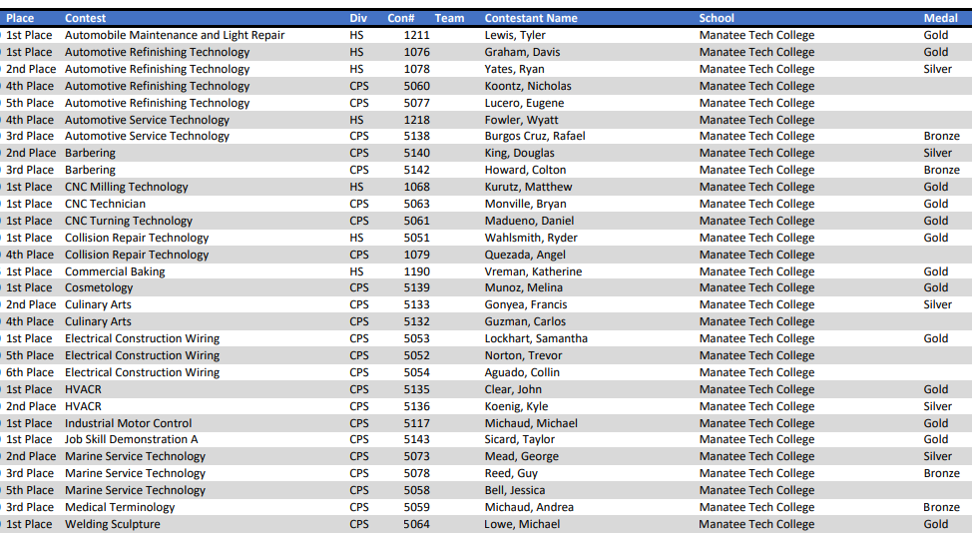

**2021 Florida HOSA Future Health Professionals**

**Place Contest Div Contestant Name School Medal**

2nd Place Dental Terminology CPS Coleman, Jayshonda Manatee Tech College Silver

2nd Place Dental Science CPS Hale, Angelina Manatee Tech College Silver

2nd Place Pharmacy Science CPS Lund, Tarryn Manatee Tech College Silver

Key: HS = High School Division; CPS = College Post-Secondary Division