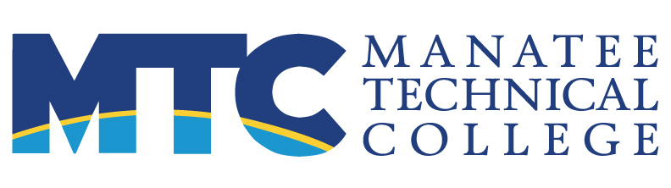 FOR IMMEDIATE RELEASE
MAIN: 6305 State Road 70 East, Bradenton, FL 34203 Contact: Maura C. Howl, APR
EAST: 5520 Lakewood Ranch Boulevard, Bradenton, FL 34211 Communications Supervisor
WEST: 5505 34th Street West, Bradenton, FL 34210 941.752.8100 x 2166
https://ManateeTech.edu howlmc@manateeschools.net

MTC firefighter students finish despite Covid

(Bradenton, FL—October 16, 2020) Three classes of Firefighter students at Manatee Technical College celebrated their program completion with an awards ceremony at 6 p.m. on October 14, 2020, at the MTC East Campus. Over 70 family and friends attended via Zoom to watch the presentation, as students sat socially distanced in the Dr. Priscilla Haflich Auditorium.
Nine students from classes 40, 41 and HS10 received awards, three per class. Award winners were as follows:
Academic Achievement: Kasey Truman (Class 40), Jared Dole (Class 41), and Samuel Lesak (High School Class 10);
Overall Skills: Morgan Sweat (Class 40), Trace Parcels (Class 41), and James Fowler (HS10);
Physical Agility, aka Combat Challenge: Jonathan Dias (40), Matthew Krames (41), and James Fowler (HS10).
Notable achievements:
- Class 40 had the highest achievers of the three classes.
- Class 41 started on April 13 during the shutdown.
- James Fowler of High School Class 10 won two of the three awards for his class.
EMS/Fire Program Director Jay Bush presented the awards. He was joined by Fire Academy instructors in congratulating the 34 students who completed.
This was the first awards ceremony led by Bush, who took over the fire program after the former program coordinator, Henry Sheffield, passed away in December 2019.

About Manatee Technical College
Manatee Technical College is accredited by the Council on Occupational Education and the Southern Association of Colleges and Schools. MTC has three campuses within the School District of Manatee County and offers over 50 career preparation programs, continuing education, adult general education. The mission of MTC is to produce highly skilled individuals and resourceful leaders through collaborative education to meet the ever-changing needs of our communities and the workforce.
###

