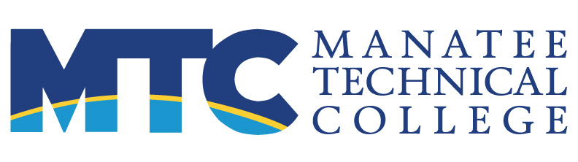 FOR IMMEDIATE RELEASE
MAIN: 6305 State Road 70 East, Bradenton, FL 34203 Contact: Maura C. Howl, APR
EAST: 5520 Lakewood Ranch Boulevard, Bradenton, FL 34211 Communications Supervisor
WEST: 5505 34th Street West, Bradenton, FL 34210 941.752.8100 x 2166
https://ManateeTech.edu howlmc@manateeschools.net

Manatee Technical College partners with Florida Department of Education on new workforce education initiative
“Get There” positions career and technical education as solution to workforce needs

(Bradenton, FL—October 13, 2020) Manatee Technical College is joining forces with the Florida Department of Education (FDOE) for a new workforce education initiative aimed at raising awareness of short-term career and technical education programs. Get There Florida highlights the key benefits of the programs available locally in Manatee County and to all Floridians statewide.

“Manatee Technical College is excited to be a part of this new initiative,” said MTC director Dr. Valerie Viands. “MTC plays a vital role in workforce education in our area—training our students for high-skill, high-wage jobs, giving our high school students a chance to dual enroll, and linking graduates with aspirations of higher education to our state colleges.”

Career and technical education, often referred to as “CTE,” serves as a critical component in preparing individuals for occupations important to Florida’s economic development. Program offerings are organized into 17 career paths and are geared toward middle school, high school, district technical school and Florida College System students throughout the state.

“Get There accelerates student success, preparing them for their future and ensuring a talented workforce,” said Kathy Hebda, Chancellor of the Florida College System. “With 28 state colleges and 48 technical colleges and centers spanning the state, there is a program for everyone. Whether you’ve recently experienced job loss, graduated high school or are simply looking for a career change or opportunity to stack your credentials into a degree – we want to help you Get There.”

At Manatee Technical College students can enroll in an in-demand, high-quality workforce program, move quickly, and gain critical skills needed in the Bradenton Area’s essential and emerging industries. Programs include:

Advanced Manufacturing, Applied Cybersecurity, CNC Production Technology, Electrical and Instrumentation Technology, Medical Lab Assisting, and Practical Nursing

“Career and technical education matters more than ever,” said Henry Mack, Chancellor for Career, Technical and Adult Education. “Get There raises awareness about CTE and helps everyone envision the power of a workforce training opportunity for professional and personal wellbeing. By connecting students to high value credentials at our technical and state colleges, we will be sure to reach our goal of becoming #1 in workforce education by 2030.”

At GetThereFL.com, Floridians can learn more about CTE and workforce training programs available at state and technical colleges, align their interests with a career path and connect with their local institution to enroll.

MTC is taking applications now for its January term. Most programs can be completed in less than a year. In response to the current job crisis, MTC is offering Rapid Credential programs that also lead to essential work and can be completed in less than six months. For program information, please visit the MTC website at https://www.ManateeTech.edu.

About Manatee Technical College
Manatee Technical College is accredited by the Council on Occupational Education and the Southern Association of Colleges and Schools. MTC has three campuses within the School District of Manatee County and offers over 50 career preparation programs, continuing education, adult general education. The mission of MTC is to produce highly skilled individuals and resourceful leaders through collaborative education to meet the ever-changing needs of our communities and the workforce.
###

