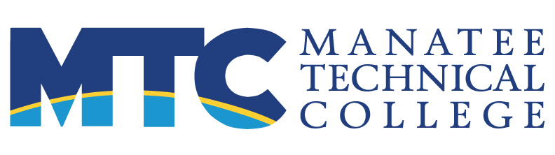 FOR IMMEDIATE RELEASE
MAIN: 6305 State Road 70 East, Bradenton, FL 34203 Contact: Maura C. Howl, APR
EAST: 5520 Lakewood Ranch Boulevard, Bradenton, FL 34211 941.752.8100 x 2166
WEST: 5505 34th Street West, Bradenton, FL 34210 howlmc@manateeschools.net
http://ManateeTech.edu

MTC students medal at national & international contests

(Bradenton, FL—June 30, 2021) Four Manatee Technical College students medaled at international and national competitions this past week.
Tarryn Lund won a gold medal in the Pharmacy Science contest during the 2021 HOSA Future Health Professionals Virtual International Leadership Conference. Lund competed in the college division, where the competition includes university students. She is graduating from the Pharmacy Technician program at MTC’s East Campus.
Three MTC students medaled at the 2021 SkillsUSA National Championships, which were also conducted virtually this year.
In the college division, Samantha Lockhart won first in the nation in Electrical Construction Wiring, and Taylor Sicard won third in the nation in the Job Demonstration A contest. Lockhart is graduating from the Electrician program, and Sicard is graduating from the Cosmetology program at MTC’s Main Campus.
In the high school division, Katherine Vreman won second in the nation in Commercial Baking. Vreman is a student in MTC’s Baking and Pastry Arts program at the Main Campus.
HOSA is a global student-led organization recognized by the U.S. Department of Education and the Department of Health and Human Services. SkillsUSA is a partnership of students, teachers and industry working together to ensure America has a skilled workforce.
About Manatee Technical College
Manatee Technical College is accredited by the Council on Occupational Education and the Southern Association of Colleges and Schools. MTC has three campuses within the School District of Manatee County and offers over 50 career preparation programs, as well as continuing education and adult general education classes. The mission of MTC is to produce highly skilled individuals and resourceful leaders through collaborative education to meet the ever-changing needs of our communities and the workforce.
###

